

Topic :

Make the Website using the rule of Human Computer Interaction

Subject :

Human Computer Interaction

Submitted to:

SIR Adeel Ahmed

Submitted by:

Mubashir Husnain

Roll Number:

13014198-051

Section:

BS-SE

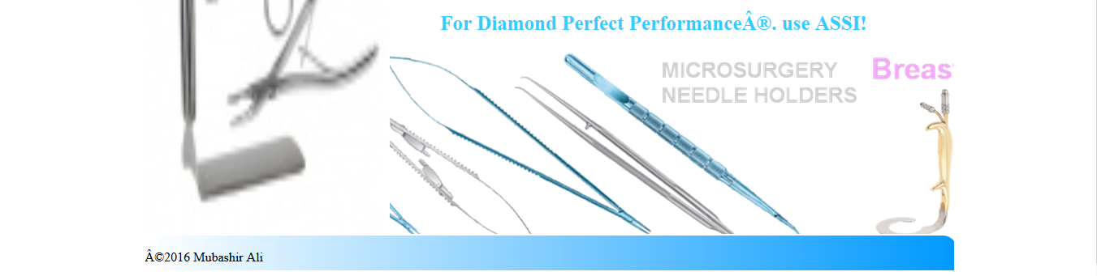

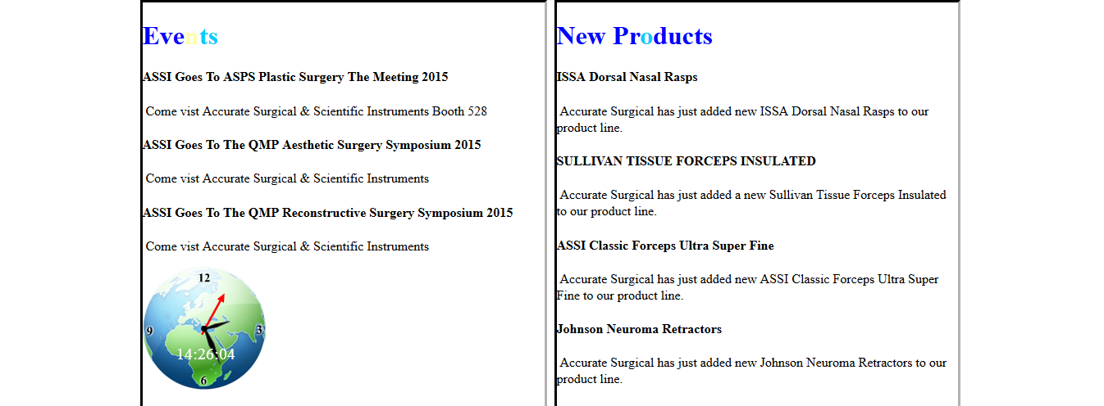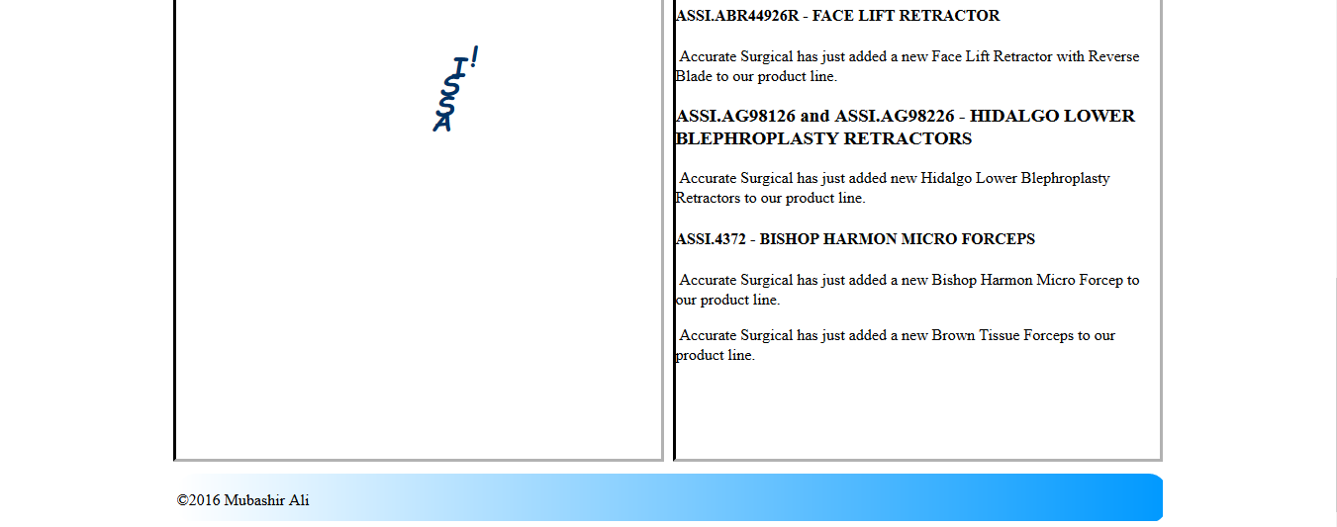

Design Explaination:

* First of all I choose blue, white and, black color in all application because a color blind will also be able to use it.
* This is simple and Attractive website..
* Here, screen shot of only two pages available. Home page, News and Events.
* Home Page is only for some information, other background color of some part are blue use because it is blind color respectively.
* Mouse Hover is used in website.
* On the top of pages use only Name and related Image of website.
* Bellow that part the button are place here which are using for going to the next page for the detail of website.
* In product page the products which are available are placed with images because user can easily read.
* In About Us page detail Information about website are available.
* In News and Event Page the Events and News are available which also on screen shot.

Slider are used on images and different tag also used in Page.

* For Title size and font is Times New Roman, 27.75pt and label size and font Times New Roman, 15.75pt. Difference will make a focus on Title firstly and then on labels.
* Times New Roman is used because it is good for web applications.
* The size of text field length in online query page are same because different size of length make confusion…